|  |  |
| --- | --- |
| **PMP**  **Detailed Design Document** | |
| **Summary** | This is the Software Detailed Design Document for the PMP component of *DAIMLER MMA* Project. |

|  |  |  |
| --- | --- | --- |
| **Author** | **Review** | **Approval** |
| SW Dev: Septimiu-Darex C. Vintila | SW Arch: Andreea Negrea | SW PM: Andris Daniel |
|  |  |  |
| **Distribution** | | |
| See Project Master Document for the roles and Project Members List for the name of people | See Project Master Document for the roles and Project Members List for the name of people | See Project Master Document for the roles and Project Members List for the name of people |

# Table of content

1.1. Revision history * 5

1.2. Purpose and Scope 5

1.3. Referenced documents 5

1.3.1. External documents 5

1.3.2. Internal Documents 5

1.3.3. Terminology and definitions 5

2.1. Overview 7

2.2. Traceability 7

3.1. Services 13

3.1.1. PMP_Init 13

3.1.2. PMP_runComputeDeficiencyLevel 14

3.1.3. PMP_runGetFilteredTemperature 15

3.1.4. PMP_runGetFilteredTemperature_deg 16

3.1.5. PMP_runSurveyBatteryVoltage 17

3.1.6. PMP_runGetBatteryVoltage 19

3.1.7. PMP_runGetBatteryVoltage_2ms 19

3.1.8. PMP_runGetBatteryVoltage_10ms 20

3.1.9. PMP_runGetDeficiencyLevel 21

3.1.10. PMP_runGetMotorResistance 22

3.1.11. pmp_GetCorrectedTemperature 22

3.1.12. pmp_runGetBatteryVoltage 23

3.1.13. pmp_runGetBatteryVoltage_20ms 24

3.1.14. pmp_runGetBatteryVoltage_100ms 25

3.1.15. pmp_runGetBatteryVoltage_10ms 26

3.1.16. pmp_runGetBatteryVoltage_2ms 27

3.1.17. PMP_runGetBoardResistance 28

3.1.18. PMP_runGetMotorVn 29

3.1.19. PMP_runGetMotorVn_20ms 30

3.1.20. PMP_runGetMotorVn_100ms 30

3.1.21. PMP_runGetMotorVp 31

3.1.22. PMP_runGetMotorVp_20ms 32

3.1.23. PMP_runGetMotorVp_100ms 33

3.1.24. PMP_runGetHS1Level 34

3.1.25. PMP_runGetBatteryVoltageSurveyStatus 34

3.2. Auto-Tests 35

3.2.1. PMP_Autotest_CheckTemperatureSensor 35

3.2.2. PMP_Autotest_CheckPowerSupplyOV 36

3.2.3. PMP_Autotest_CheckPowerSupplyUV 37

3.2.4. PMP_Autotest_CheckPowerSupplyUVDuringActivation 38

3.2.5. PMP_Autotest_CheckPowerSupplyOVDuringActivation 39

3.2.6. PMP_Autotest_CheckSystemUV 40

3.2.7. PMP_Autotest_CheckSystemOV 41

3.3. Types 42

3.3.1. PMP_stBatterySurveyParamType 42

3.4. Variables 43

3.4.1. PMP_stBatterySurveyParam 43

3.4.2. PMP_u16OldADCTemperature_LSB 43

3.4.3. PMP_u16OldCorrectedTemperature_LSB 43

3.5. Macros 43

3.5.1. PMP_KU8_MOTOR_RESISTANCE_LINEAR_INTERPOLATION_NB_POINTS 43

3.5.2. PMP_RIGHT_ALIGNED_ADC 43

3.5.3. PMP_LEFT_ALIGNED_ADC 44

3.5.4. PMP_ALIGNMENT_ADC_CHANNELS 44

3.5.5. PMP_KU16_ADC_10BIT_RANGE 44

3.5.6. PMP_KU16_ADC_8BIT_RANGE 44

3.5.7. PMP_KU16_ADC_FULL_RANGE 44

3.5.8. PMP_KU16_ADC_REFERENCE_MV 44

3.5.9. PMP_KU32_HVI_INTERNAL_FACTOR 45

3.5.10. PMP_KU32_KL30_RAW_MUL_FACTOR 45

3.5.11. PMP_KU32_KL30_RAW_DIV_FACTOR 45

3.5.12. PMP_KU32_KL30_MUL_FACTOR 45

3.5.13. PMP_KU32_KL30_DIV_FACTOR 45

3.5.14. PMP_KU32_VN_MUL_FACTOR 46

3.5.15. PMP_KU32_VN_DIV_FACTOR 46

3.5.16. PMP_KU32_VP_MUL_FACTOR 46

3.5.17. PMP_KU32_VP_DIV_FACTOR 46

3.5.18. PMP_KU32_HS_MUL_FACTOR 46

3.5.19. PMP_KU32_HS_DIV_FACTOR 47

3.5.20. PMP_KU32_REFLOW_MUL_FACTOR 47

3.5.21. PMP_KU32_REFLOW_DIV_FACTOR 47

3.5.22. PMP_KU32_REFMID_MUL_FACTOR 47

3.5.23. PMP_KU32_REFMID_DIV_FACTOR 47

3.5.24. PMP_KU32_REFHIGH_MUL_FACTOR 47

3.5.25. PMP_KU32_REFHIGH_DIV_FACTOR 48

3.5.26. PMP_KU32_REFCPUREG_MUL_FACTOR 48

3.5.27. PMP_KU32_REFCPUREG_DIV_FACTOR 48

3.5.28. PMP_KU16_ADC_RANGE_MV 48

3.5.29. PMP_KU16_ADC_OUT_SCALE 48

3.5.30. PMP_KU8_NB_INTERP_PTS_TEMP_CALIB 49

3.5.31. PMP_KU8_DEG_RANGE 49

3.5.32. PMP_KU8_DEG_LOW_RANGE 49

3.5.33. PMP_KU32_TYP_H_SLOPE_UV_PER_DEG 49

3.5.34. PMP_KU16_ADC_OUT_H_SCALE 49

3.5.35. PMP_KU32_ADC_RANGE_UV 49

3.5.36. PMP_KU32_ADC_H_RANGE_UV 50

3.5.37. PMP_KU32_REF_TEMP_UV 50

3.5.38. PMP_KU32_ADC_INPUT_UV 50

3.5.39. PMP_KU32_ADC_OUTPUT 50

3.5.40. PMP_KU32_REF_TEMP_ADC 50

3.5.41. PMP_KS16_ADC_TO_DEG 51

3.5.42. PMP_KU16_DEG_TO_ADC 51

3.5.43. PMP_KU16_COMPUTE_TEMP_SLOP 51

3.5.44. PMP_KU16_FIX_TEMP_ADC 51

3.5.45. PMP_KU32_TYP_SLOPE_UV_PER_DEG 52

3.5.46. PMP_KU16_REF_TEMP_DEG 52

3.5.47. PMP_KU16_REF_TEMP_MV 52

3.5.48. PMP_KS16_TEMP_HIGH 52

3.5.49. PMP_KU32_TWO 52

3.5.50. PMP_KU32_ONE_HUNDRED 53

3.5.51. PMP_KU16_ADC_LEFT_ALIGNED_BIT_SHIFT 53

3.5.52. PMP_KU16_FIVE_HUNDRED 53

3.5.53. PMP_KU8_NO_REQUEST 53

# Tables of figures

Figure 1: PMP_Init diagram 14

Figure 2: PMP_runComputeDeficiencyLevel diagram 15

Figure 3: PMP_runGetFilteredTemperature diagram 16

Figure 4: PMP_runGetFilteredTemperature_deg diagram 17

Figure 5: PMP_runSurveyBatteryVoltage diagram 18

Figure 6: PMP_runGetBatteryVoltage diagram 19

Figure 7: PMP_runGetBatteryVoltage_2ms diagram 20

Figure 8: PMP_runGetBatteryVoltage_10ms diagram 21

Figure 9: PMP_runGetDeficiencyLevel diagram 22

Figure 10: PMP_runGetMotorResistance diagram 22

Figure 11 pmp_GetCorrectedTemperature 23

Figure 12 PMP_runGetBatteryVoltage 24

Figure 13 PMP_runGetBatteryVoltage_20ms 25

Figure 14 PMP_runGetBatteryVoltage_100ms 26

Figure 15 PMP_runGetBatteryVoltage_10ms 27

Figure 16 PMP_runGetBatteryVoltage_2ms 28

Figure 17 PMP_runGetBoardResistance 29

Figure 18 PMP_runGetMotorVn 30

Figure 19 PMP_runGetMotorVn_20ms 30

Figure 20 PMP_runGetMotorVn_100ms 31

Figure 21 PMP_runGetMotorVp 32

Figure 22 PMP_runGetMotorVp_20ms 33

Figure 23 PMP_runGetMotorVp_100ms 33

Figure 24 PMP_runGetHS1Level 34

Figure 25 PMP_runGetBatteryVoltageSurveyStatus 35

Figure 26 PMP_Autotest_CheckTemperatureSensor 36

Figure 27 PMP_Autotest_CheckPowerSupplyOV 37

Figure 28 PMP_Autotest_CheckPowerSupplyUV 38

Figure 29 PMP_Autotest_CheckPowerSupplyUVDuringActivation 39

Figure 30 PMP_Autotest_CheckPowerSupplyOVDuringActivation 40

Figure 31 PMP_Autotest_CheckSystemUV 41

Figure 32 PMP_Autotest_CheckSystemOV 42

# General Information

## Revision history *

|  |  |  |  |
| --- | --- | --- | --- |
| **Revision** | **Date** | **Author(s)** | **Description/comment** |
| 1.1.3.1 | 07.01.2022 | Septimiu-Darex C. Vintila | Initial revision. |
| 1.1.3.2 | 07.01.2022 | Septimiu-Darex C. Vintila | Services added. |
| 1.1.3.3 | 09.02.2022 | Septimiu-Darex C. Vintila | Corrections after review. |
| 1.1.3.4 | 24.03.2022 | Septimiu-Darex C. Vintila | Add new requirements. |
| 1.1.3.5 | 29.03.2022 | Septimiu-Darex C. Vintila | Typo in requirements source corrected. |
| 1.1.3.6 | 11.04.2022 | Septimiu-Darex C. Vintila | Distribution fields updated. |
| 1.1.3.7 | 15.06.2022 | Obada Mirela | New autotests and traceability added |
| 1.1.3.8 | 17.06.2022 | Obada Mirela | Update after review |
| 1.1.3.9 | 22.06.2022 | Obada Mirela | Update fnctions template |
| 1.1.3.10 | 06.09.2022 | Madalina Serban | Added new functions and traceability |
| 1.1.3.11 | 08.09.2022 | Madalina Serban | Fixed review findings |
| 1.1.3.12 | 10.02.2023 | Mirela Obada | Update traceability for 5.0 |
| 1.1.3.13 | 15.02.2023 | Mirela Obada | Update for 5.0 |
| 1.1.3.14 | 16.02.2023 | Mirela Obada | Update for 5.0 after new corrections of architecture |
| 1.1.3.15 | 03.05.2023 | Mirela Obada | Update for 6.0 |
| 1.1.3.16 | 03.05.2023 | Mirela Obada | Update after review |
| 1.1.3.17 | 04.10.2023 | Mirela Obada | Update UVT & OVT autotests diagrams |

*\* Template history is found in the CM tool used for templates*

## Purpose and Scope

The purpose of this document is to establish the functionality and behavior of the PMP component

## Referenced documents

### External documents

|  |  |  |
| --- | --- | --- |
| **Id** | **Title** | **Reference** |
|  |  |  |
|  |  |  |
|  |  |  |

### Internal Documents

|  |  |  |
| --- | --- | --- |
| **Id** | **Title** | **Reference** |
|  |  |  |
|  |  |  |
|  |  |  |
|  |  |  |

### Terminology and definitions

The generic acronyms are available in the [AEM process and method wiki](https://alvteams.alv.autoliv.int/sites/aeuaeequalityassurance/AEM%20Process%20wiki/acronyms.aspx)

|  |  |
| --- | --- |
| **Terminology** | **Meaning** |
| AAU | Atomic architectural unit |
| SW | software |
| PMP | Physical Measures Provider |

# SW atomic architectural unit design

## Overview

The PMP (Physical Measures Provider) component is intended to provide the value of all physical signals (sampled by the ADC component) including the associated filtered values (issued from an IIR filter at different periods: 2ms, 10ms, 20ms and 100ms for the rest of the application).

## Traceability

|  |  |  |  |
| --- | --- | --- | --- |
| Requirements | Criteria | Linked Runnable | Source |
| DSG_PMP_0001 | The default value for the previous result of battery voltage shall be 0. | PMP_Init() | ARCH_SW_PMP_0005 |
| DSG_PMP_0002 | Maximum threshold for KL30 voltage shall be initialize with a value read from non-volatile memory and aligned to the used ADC format. | PMP_Init() | ARCH_SW_PMP_0005 |
| DSG_PMP_0003 | Minimum threshold for KL30 voltage shall be initialize with a value read from non-volatile memory and aligned to the used ADC format. | PMP_Init() | ARCH_SW_PMP_0005 |
| DSG_PMP_0004 | The default value for the battery survey state shall be KU8_BATTERY_UNSTABLE. | PMP_Init() | ARCH_SW_PMP_0005 |
| DSG_PMP_0005 | The default value for the occurrences counter shall be 0. | PMP_Init() | ARCH_SW_PMP_0005 |
| DSG_PMP_0006 | The deficiency level shall be calculated based on previous deficiency level value, the absolute value of measured motor current and the internal temperature. | PMP_runComputeDeficiencyLevel() | ARCH_SW_PMP_0340  ARCH_SW_PMP_9006  ARCH_SW_PMP_9007  ARCH_SW_PMP_9008  ARCH_SW_PMP_0341  ARCH_SW_PMP_9001  ARCH_SW_PMP_9002  ARCH_SW_PMP_9003 |
| DSG_PMP_0007 | In case the motor current is null and the previous deficiency level value is below the related threshold, the deficiency level shall become null. | PMP_runComputeDeficiencyLevel() | ARCH_SW_PMP_0340  ARCH_SW_PMP_9004  ARCH_SW_PMP_9001  ARCH_SW_PMP_9003 |
| DSG_PMP_0008 | In case the motor current is null and the previous deficiency level value is over the related threshold, the deficiency level shall be the difference between the previous deficiency level value and the threshold. | PMP_runComputeDeficiencyLevel() | ARCH_SW_PMP_0340  ARCH_SW_PMP_9004  ARCH_SW_PMP_9001  ARCH_SW_PMP_9003 |
| DSG_PMP_0009 | In case the calculated deficiency level exceeds the authorized range, the deficiency level value shall be saturated to the related threshold value. | PMP_runComputeDeficiencyLevel() | ARCH_SW_PMP_0340  ARCH_SW_PMP_9005  ARCH_SW_PMP_9003 |
| DSG_PMP_0010 | The filtered temperature (in degree) shall be made available to the rest of the application. | PMP_runGetFilteredTemperature() PMP_runGetFilteredTemperature_deg() | ARCH_SW_PMP_0260  ARCH_SW_PMP_0280  ARCH_SW_PMP_0285 |
| DSG_PMP_0011 | The corrected temperature (in degree) shall be made available to the rest of the application. | pmp_GetCorrectedTemperature() | ARCH_SW_PMP_9014  ARCH_SW_PMP_0265 |
| DSG_PMP_0012 | The stability of the battery voltage shall be monitored based on consecutive measurements of the KL30 voltage. | PMP_runSurveyBatteryVoltage() | ARCH_SW_PMP_0200  ARCH_SW_PMP_0201  ARCH_SW_PMP_0202 |
| DSG_PMP_0013 | In case the measured battery voltage is outside the authorized range, the battery voltage status shall take the value KU8_BATTERY_UNSTABLE. | PMP_runSurveyBatteryVoltage() | ARCH_SW_PMP_0200  ARCH_SW_PMP_0201  ARCH_SW_PMP_0202 |
| DSG_PMP_0014 | In case the measured battery voltage is in the authorized range and the variation between two consecutive measurements is in range, the battery voltage status shall take the value KU8_BATTERY_STABLE. | PMP_runSurveyBatteryVoltage() | ARCH_SW_PMP_0200 |
| DSG_PMP_0015 | In case the measured battery voltage is in the authorized range and the variation between two consecutive measurements is outside range, the battery voltage status shall take the value KU8_BATTERY_UNSTABLE. | PMP_runSurveyBatteryVoltage() | ARCH_SW_PMP_0200 |
| DSG_PMP_0016 | The raw battery voltage shall be updated every 1ms. | PMP_runGetBatteryVoltage() | ARCH_SW_PMP_0010  ARCH_SW_PMP_0020  ARCH_SW_PMP_0210 |
| DSG_PMP_0017 | The raw battery voltage shall be updated every 2ms and made available to the system. | PMP_runGetBatteryVoltage_2ms() | ARCH_SW_PMP_0011  ARCH_SW_PMP_0020 |
| DSG_PMP_0018 | The raw battery voltage shall be updated every 10ms and made available to the system. | PMP_runGetBatteryVoltage_10ms() | ARCH_SW_PMP_0012  ARCH_SW_PMP_0020 |
| DSG_PMP_0019 | The raw battery voltage shall be updated every 100ms and made available to the system. | PMP_runGetBatteryVoltage_100ms() | ARCH_SW_PMP_0014  ARCH_SW_PMP_0020 |
| DSG_PMP_0020 | The motor resistance regarding the temperature shall be computed using a NVP look-up table. | PMP_runGetMotorResistance() | ARCH_SW_PMP_0383; ARCH_SW_PMP_0384; ARCH_SW_PMP_0385; |
| DSG_PMP_0021 | The calculated deficiency level shall made available to the rest of the application. | PMP_runGetDeficiencyLevel() | ARCH_SW_PMP_0320 |
| DSG_PMP_0022 | Power Overvoltage Autotest shall be executed every 10 ms. | PMP_Autotest_CheckPowerSupplyOV() | ARCH_SW_PMP_1000; ARCH_SW_PMP_1001; ARCH_SW_PMP_1005; ARCH_SW_PMP_1007; ARCH_SW_PMP_1008 |
| DSG_PMP_0023 | In case an undervoltage was detected, the Power Overvoltage Autotest shall return KU8_ATM_TEST_NOT_DECIDED. | PMP_Autotest_CheckPowerSupplyOV() | ARCH_SW_PMP_1000; ARCH_SW_PMP_1001; ARCH_SW_PMP_1005; ARCH_SW_PMP_1007; ARCH_SW_PMP_1008 |
| DSG_PMP_0024 | In case an overvoltage was previously detected and the measured voltage is below the deskilling threshold, the Power Overvoltage Autotest shall return KU8_ATM_TEST_OK. | PMP_Autotest_CheckPowerSupplyOV() | ARCH_SW_PMP_1000; ARCH_SW_PMP_1001; ARCH_SW_PMP_1005; ARCH_SW_PMP_1007; ARCH_SW_PMP_1008 |
| DSG_PMP_0025 | In case an overvoltage was previously detected and the measured voltage is over the deskilling threshold, the Power Overvoltage Autotest shall return KU8_ATM_TEST_NOK. | PMP_Autotest_CheckPowerSupplyOV() | ARCH_SW_PMP_1000; ARCH_SW_PMP_1001; ARCH_SW_PMP_1005; ARCH_SW_PMP_1007; ARCH_SW_PMP_1008 |
| DSG_PMP_0026 | In case an no overvoltage was previously detected and the measured voltage is below the qualification threshold, the Power Overvoltage Autotest shall return KU8_ATM_TEST_OK. | PMP_Autotest_CheckPowerSupplyOV() | ARCH_SW_PMP_1000; ARCH_SW_PMP_1001; ARCH_SW_PMP_1005; ARCH_SW_PMP_1007; ARCH_SW_PMP_1008 |
| DSG_PMP_0027 | In case an no overvoltage was previously detected and the measured voltage is over the qualification threshold, the Power Overvoltage Autotest shall return KU8_ATM_TEST_NOK. | PMP_Autotest_CheckPowerSupplyOV() | ARCH_SW_PMP_1000; ARCH_SW_PMP_1001; ARCH_SW_PMP_1005; ARCH_SW_PMP_1007; ARCH_SW_PMP_1008 |
| DSG_PMP_0028 | Power Undervoltage Autotest shall be executed every 10 ms. | PMP_Autotest_CheckPowerSupplyUV() | ARCH_SW_PMP_1050; ARCH_SW_PMP_1051; ARCH_SW_PMP_1055; ARCH_SW_PMP_1057; ARCH_SW_PMP_1058; ARCH_SW_PMP_1059; |
| DSG_PMP_0029 | In case an overvoltage was detected, the Power Undervoltage Autotest shall return KU8_ATM_TEST_NOT_DECIDED. | PMP_Autotest_CheckPowerSupplyUV() | ARCH_SW_PMP_1050; ARCH_SW_PMP_1051; ARCH_SW_PMP_1055; ARCH_SW_PMP_1057; ARCH_SW_PMP_1058; ARCH_SW_PMP_1059; |
| DSG_PMP_0030 | In case an undervoltage was previously detected and the measured voltage is over the deskilling threshold, the Power Undervoltage Autotest shall return KU8_ATM_TEST_OK. | PMP_Autotest_CheckPowerSupplyUV() | ARCH_SW_PMP_1050; ARCH_SW_PMP_1051; ARCH_SW_PMP_1055; ARCH_SW_PMP_1057; ARCH_SW_PMP_1058; ARCH_SW_PMP_1059; |
| DSG_PMP_0031 | In case an undervoltage was previously detected and the measured voltage is under the deskilling threshold, the Power Undervoltage Autotest shall return KU8_ATM_TEST_NOK. | PMP_Autotest_CheckPowerSupplyUV() | ARCH_SW_PMP_1050; ARCH_SW_PMP_1051; ARCH_SW_PMP_1055; ARCH_SW_PMP_1057; ARCH_SW_PMP_1058; ARCH_SW_PMP_1059; |
| DSG_PMP_0032 | In case an no undervoltage was previously detected and the measured voltage is over the qualification threshold, the Power Undervoltage Autotest shall return KU8_ATM_TEST_OK. | PMP_Autotest_CheckPowerSupplyUV() | ARCH_SW_PMP_1050; ARCH_SW_PMP_1051; ARCH_SW_PMP_1055; ARCH_SW_PMP_1057; ARCH_SW_PMP_1058; ARCH_SW_PMP_1059; |
| DSG_PMP_0033 | In case an no undervoltage was previously detected and the measured voltage is under the qualification threshold, the Power Undervoltage Autotest shall return KU8_ATM_TEST_NOK. | PMP_Autotest_CheckPowerSupplyUV() | ARCH_SW_PMP_1050; ARCH_SW_PMP_1051; ARCH_SW_PMP_1055; ARCH_SW_PMP_1057; ARCH_SW_PMP_1058; ARCH_SW_PMP_1059; |
| DSG_PMP_0034 | The sampled value of the unfiltered ECU temperature shall be taken from the ADC. | PMP_runGetFilteredTemperature() | ARCH_SW_PMP_9009 |
| DSG_PMP_0035 | Power Undervoltage Autotest During Activation shall be executed every 10 ms. | PMP_Autotest_CheckPowerSupplyUVDuringActivation () | ARCH_SW_PMP_1060; ARCH_SW_PMP_1061; ARCH_SW_PMP_1065; ARCH_SW_PMP_1067; ARCH_SW_PMP_1080; ARCH_SW_PMP_1068; ARCH_SW_PMP_1069; ARCH_SW_PMP_1064 |
| DSG_PMP_0036 | In case an overvoltage was detected, the Power Undervoltage Autotest shall return KU8_ATM_TEST_NOT_DECIDED. | PMP_Autotest_CheckPowerSupplyUVDuringActivation() | ARCH_SW_PMP_1060; ARCH_SW_PMP_1061; ARCH_SW_PMP_1065; ARCH_SW_PMP_1067; ARCH_SW_PMP_1080; ARCH_SW_PMP_1068; ARCH_SW_PMP_1069; ARCH_SW_PMP_1064 |
| DSG_PMP_0037 | In case an undervoltage was previously detected and the measured voltage is over the deskilling threshold, the Power Undervoltage During Activation Autotest shall return KU8_ATM_TEST_OK. | PMP_Autotest_CheckPowerSupplyUVDuringActivation() | ARCH_SW_PMP_1060; ARCH_SW_PMP_1061; ARCH_SW_PMP_1065; ARCH_SW_PMP_1067; ARCH_SW_PMP_1080; ARCH_SW_PMP_1068; ARCH_SW_PMP_1069; ARCH_SW_PMP_1064 |
| DSG_PMP_0038 | In case an undervoltage was previously detected and the measured voltage is under the deskilling threshold, the Power Undervoltage Autotest During Activation shall return KU8_ATM_TEST_NOK. | PMP_Autotest_CheckPowerSupplyUVDuringActivation () | ARCH_SW_PMP_1060; ARCH_SW_PMP_1061; ARCH_SW_PMP_1065; ARCH_SW_PMP_1067; ARCH_SW_PMP_1080; ARCH_SW_PMP_1068; ARCH_SW_PMP_1069; ARCH_SW_PMP_1064 |
| DSG_PMP_0039 | In case an no undervoltage was previously detected and the measured voltage is over the qualification threshold, the Power Undervoltage During Activation Autotest shall return KU8_ATM_TEST_OK. | PMP_Autotest_CheckPowerSupplyUVDuringActivation () | ARCH_SW_PMP_1060; ARCH_SW_PMP_1061; ARCH_SW_PMP_1065; ARCH_SW_PMP_1067; ARCH_SW_PMP_1080; ARCH_SW_PMP_1068; ARCH_SW_PMP_1069; ARCH_SW_PMP_1064 |
| DSG_PMP_0040 | In case an no undervoltage was previously detected and the measured voltage is under the qualification threshold, the Power Undervoltage Autotest During Activation shall return KU8_ATM_TEST_NOK. | PMP_Autotest_CheckPowerSupplyUVDuringActivation () | ARCH_SW_PMP_1060; ARCH_SW_PMP_1061; ARCH_SW_PMP_1065; ARCH_SW_PMP_1067; ARCH_SW_PMP_1080; ARCH_SW_PMP_1068; ARCH_SW_PMP_1069; ARCH_SW_PMP_1064; |
| DSG_PMP_0041 | Power Overvoltage Autotest shall be executed every 10 ms. | PMP_Autotest_CheckPowerSupplyOVDuringActivation () | ARCH_SW_PMP_1070; ARCH_SW_PMP_1071; ARCH_SW_PMP_1075; ARCH_SW_PMP_1077; ARCH_SW_PMP_1078; ARCH_SW_PMP_1079; ARCH_SW_PMP_1090; |
| DSG_PMP_0042 | In case an undervoltage was detected, the Power Overvoltage Autotest shall return KU8_ATM_TEST_NOT_DECIDED. | PMP_Autotest_CheckPowerSupplyOVDuringActivation () | ARCH_SW_PMP_1070; ARCH_SW_PMP_1071; ARCH_SW_PMP_1075; ARCH_SW_PMP_1077; ARCH_SW_PMP_1078; ARCH_SW_PMP_1079; ARCH_SW_PMP_1090; |
| DSG_PMP_0043 | In case an overvoltage was previously detected and the measured voltage is below the deskilling threshold, the Power Overvoltage Autotest shall return KU8_ATM_TEST_OK. | PMP_Autotest_CheckPowerSupplyOVDuringActivation () | ARCH_SW_PMP_1070; ARCH_SW_PMP_1071; ARCH_SW_PMP_1075; ARCH_SW_PMP_1077; ARCH_SW_PMP_1078; ARCH_SW_PMP_1079; ARCH_SW_PMP_1090; |
| DSG_PMP_0044 | In case an overvoltage was previously detected and the measured voltage is over the deskilling threshold, the Power Overvoltage Autotest shall return KU8_ATM_TEST_NOK. | PMP_Autotest_CheckPowerSupplyOVDuringActivation () | ARCH_SW_PMP_1070; ARCH_SW_PMP_1071; ARCH_SW_PMP_1075; ARCH_SW_PMP_1077; ARCH_SW_PMP_1078; ARCH_SW_PMP_1079; ARCH_SW_PMP_1090; |
| DSG_PMP_0045 | In case an no overvoltage was previously detected and the measured voltage is below the qualification threshold, the Power Overvoltage Autotest shall return KU8_ATM_TEST_OK. | PMP_Autotest_CheckPowerSupplyOVDuringActivation () | ARCH_SW_PMP_1070; ARCH_SW_PMP_1071; ARCH_SW_PMP_1075; ARCH_SW_PMP_1077; ARCH_SW_PMP_1078; ARCH_SW_PMP_1079; ARCH_SW_PMP_1090; |
| DSG_PMP_0046 | In case an no overvoltage was previously detected and the measured voltage is over the qualification threshold, the Power Overvoltage Autotest shall return KU8_ATM_TEST_NOK. | PMP_Autotest_CheckPowerSupplyOVDuringActivation () | ARCH_SW_PMP_1070; ARCH_SW_PMP_1071; ARCH_SW_PMP_1075; ARCH_SW_PMP_1077; ARCH_SW_PMP_1090; ARCH_SW_PMP_1078; ARCH_SW_PMP_1079; |
| DSG_PMP_0047 | In case the previous autotest result for ADC is KU8_ATM_TEST_OK, the autotest shall return KU8_ATM_TEST_OK. | PMP_Autotest_CheckTemperatureSensor() | ARCH_SW_PMP_1081; ARCH_SW_PMP_1082; |
| DSG_PMP_0048 | In case the previous autotest result for ADC is KU8_ATM_TEST_NOK, the autotest shall return KU8_ATM_TEST_NOK. | PMP_Autotest_CheckTemperatureSensor() | ARCH_SW_PMP_1081; ARCH_SW_PMP_1082; |
| DSG_PMP_0049 | In case an overvoltage was previously detected and the measured voltage is below the deskilling threshold, Autotest shall return KU8_ATM_TEST_OK. | PMP_Autotest_CheckSystemOV () | ARCH_SW_PMP_1102; ARCH_SW_PMP_1101; ARCH_SW_PMP_1110; |
| DSG_PMP_0050 | In case an overvoltage was previously detected and the measured voltage is over the deskilling threshold, the Autotest shall return KU8_ATM_TEST_NOK. | PMP_Autotest_CheckSystemOV () | ARCH_SW_PMP_1102; ARCH_SW_PMP_1101; ARCH_SW_PMP_1110; |
| DSG_PMP_0051 | In case an no overvoltage was previously detected and the measured voltage is below the qualification threshold, the Overvoltage Autotest shall return KU8_ATM_TEST_OK. | PMP_Autotest_CheckSystemOV () | ARCH_SW_PMP_1102; ARCH_SW_PMP_1101; ARCH_SW_PMP_1110; |
| DSG_PMP_0052 | In case an no overvoltage was previously detected and the measured voltage is over the qualification threshold, the Autotest shall return KU8_ATM_TEST_NOK. | PMP_Autotest_CheckSystemOV () | ARCH_SW_PMP_1102; ARCH_SW_PMP_1101; ARCH_SW_PMP_1110; |
| DSG_PMP_0053 | Power Overvoltage Autotest shall be executed every 100ms. | PMP_Autotest_CheckSystemOV () | ARCH_SW_PMP_1110; |
| DSG_PMP_0054 | In case an overvoltage was detected, the Power Overvoltage Autotest shall return KU8_ATM_TEST_NOT_DECIDED. | PMP_Autotest_CheckSystemOV() | ARCH_SW_PMP_1102; ARCH_SW_PMP_1101; ARCH_SW_PMP_1110; |
| DSG_PMP_0055 | Power Undervoltage Autotest During Activation shall be executed every 100 ms. | PMP_Autotest_CheckSystemUV() | ARCH_SW_PMP_1100; ARCH_SW_PMP_1111; ARCH_SW_PMP_1112; |
| DSG_PMP_0056 | In case an overvoltage was detected, the Power Undervoltage Autotest shall return KU8_ATM_TEST_NOT_DECIDED. | PMP_Autotest_CheckSystemUV() | ARCH_SW_PMP_1100; ARCH_SW_PMP_1111; ARCH_SW_PMP_1112; |
| DSG_PMP_0057 | In case an undervoltage was previously detected and the measured voltage is over the deskilling threshold, the Power Undervoltage During Activation Autotest shall return KU8_ATM_TEST_OK. | PMP_Autotest_CheckSystemUV() | ARCH_SW_PMP_1100; ARCH_SW_PMP_1111; ARCH_SW_PMP_1112; |
| DSG_PMP_0058 | In case an undervoltage was previously detected and the measured voltage is under the deskilling threshold, the Power Undervoltage Autotest During Activation shall return KU8_ATM_TEST_NOK. | PMP_Autotest_CheckSystemUV() | ARCH_SW_PMP_1100; ARCH_SW_PMP_1111; ARCH_SW_PMP_1112; |
| DSG_PMP_0059 | In case an no undervoltage was previously detected and the measured voltage is over the qualification threshold, the Power Undervoltage During Activation Autotest shall return KU8_ATM_TEST_OK. | PMP_Autotest_CheckSystemUV() | ARCH_SW_PMP_1100; ARCH_SW_PMP_1111; ARCH_SW_PMP_1112; |
| DSG_PMP_0060 | In case an no undervoltage was previously detected and the measured voltage is under the qualification threshold, the Power Undervoltage Autotest During Activation shall return KU8_ATM_TEST_NOK. | PMP_Autotest_CheckSystemUV() | ARCH_SW_PMP_1100; ARCH_SW_PMP_1111; ARCH_SW_PMP_1112; |
| DSG_PMP_0061 | Signal PN14_SupBat_Volt_ST3 shall be converted in V in order to execute correct the autotest | PMP_Autotest_CheckSystemUV()  PMP_Autotest_CheckSystemOV() | ARCH_SW_PMP_1120; |
| DSG_PMP_0062 | The board resistance shall be made available to the rest of the application. | PMP_runGetBoardResistance() | ARCH_SW_PMP_0382; ARCH_SW_PMP_0381; |
| DSG_PMP_0063 | The HighSide switch Voltage shall be available to the rest of application | PMP_runGetHS1Level() | ARCH_SW_PMP_0203; ARCH_SW_PMP_0204; |
| DSG_PMP_0064 | The value of the Negative Motor Voltage shall be available to the rest of application | PMP_runGetMotorVn_(Ext)*() | ARCH_SW_PMP_0021; ARCH_SW_PMP_0022; |
| DSG_PMP_0065 | The value of the Positive Motor Voltage shall be available to the rest of application | PMP_runGetMotorVp_(Ext)*() | ARCH_SW_PMP_0023; ARCH_SW_PMP_0024; |
| DSG_PMP_0066 | The value of the actual battery state shall be available to the rest of application | PMP_runGetBatteryVoltageSurveyStatus | ARCH_SW_PMP_0205; ARCH_SW_PMP_0206; |

# FEATURES

## Services

### PMP_Init

|  |  |  |
| --- | --- | --- |
| Object | | |
| The function is called to initialize all the variables needed by the PMP component. | | |
| **Prototype** | | |
| void PMP_Init(void) | | |
| **Input parameters** | | |
| Name | Type | Description |
| NA | NA | NA |
| **Output parameters** | | |
| Name | Type | Description |
| NA | NA | NA |
| **Return value** | | |
| Type | Description | |
| NA | void | |
| **Dynamic aspect** | | |
| Who(callers) | Description | |
| * | * | |
| **Static aspect** | | |
| NA | | |
| **Constrains** | | |
| NA | | |

Figure : PMP_Init diagram

### PMP_runComputeDeficiencyLevel

|  |  |  |
| --- | --- | --- |
| Object | | |
| The function shall compute the estimation of the energy stored in the motor, also called deficiency level. | | |
| **Prototype** | | |
| void PMP_runComputeDeficiencyLevel(void) | | |
| **Input parameters** | | |
| Name | Type | Description |
| NA | NA | NA |
| **Output parameters** | | |
| Name | Type | Description |
| NA | NA | NA |
| **Return value** | | |
| Type | Description | |
| NA | void | |
| **Dynamic aspect** | | |
| Who(callers) | Description | |
| * | * | |
| **Static aspect** | | |
| NA | | |
| **Constrains** | | |
| NA | | |

Figure : PMP_runComputeDeficiencyLevel diagram

### PMP_runGetFilteredTemperature

|  |  |  |
| --- | --- | --- |
| Object | | |
| The function is called to provide the FILTERED and CORRECTED value of the ECU temperature in LSB | | |
| **Prototype** | | |
| void PMP_runGetFilteredTemperature_deg(s16InternalTemperature_deg_Type * ps16InternalTemperature_deg) | | |
| **Input parameters** | | |
| Name | Type | Description |
| NA | NA | NA |
| **Output parameters** | | |
| Name | Type | Description |
| pu16FilteredTemperature | u16InternalTemperatureType | Pointer used to store the requested result |
| **Return value** | | |
| Type | Description | |
| NA | void | |
| **Dynamic aspect** | | |
| Who(callers) | Description | |
| Called by BFE | * | |
| **Static aspect** | | |
| NA | | |
| **Constrains** | | |
| NA | | |

Figure : PMP_runGetFilteredTemperature diagram

### PMP_runGetFilteredTemperature_deg

|  |  |  |
| --- | --- | --- |
| Object | | |
| The function is used to provide the FILTERED and CORRECTED value of the ECU temperature in degrees. | | |
| **Prototype** | | |
| void PMP_runGetFilteredTemperature_deg(s16InternalTemperature_deg_Type * ps16InternalTemperature_deg) | | |
| **Input parameters** | | |
| Name | Type | Description |
| NA | NA | NA |
| **Output parameters** | | |
| Name | Type | Description |
| ps16InternalTemperature_deg | s16InternalTemperature_deg_Type | Pointer used to store the requested result |
| **Return value** | | |
| Type | Description | |
| NA | void | |
| **Dynamic aspect** | | |
| Who(callers) | Description | |
| Called by BFE | * | |
| **Static aspect** | | |
| NA | | |
| **Constrains** | | |
| NA | | |

Figure : PMP_runGetFilteredTemperature_deg diagram

### PMP_runSurveyBatteryVoltage

|  |  |  |
| --- | --- | --- |
| Object | | |
| The function shall be used to monitor the battery voltage. | | |
| **Prototype** | | |
| void PMP_runSurveyBatteryVoltage ( void ) | | |
| **Input parameters** | | |
| Name | Type | Description |
| NA | NA | NA |
| **Output parameters** | | |
| Name | Type | Description |
| NA | NA | NA |
| **Return value** | | |
| Type | Description | |
| NA | void | |
| **Dynamic aspect** | | |
| Who(callers) | Description | |
| Called by AdcIf | * | |
| **Static aspect** | | |
| NA | | |
| **Constrains** | | |
| NA | | |

Figure : PMP_runSurveyBatteryVoltage diagram

### PMP_runGetBatteryVoltage

|  |  |  |
| --- | --- | --- |
| Object | | |
| The function shall provide the Battery Voltage | | |
| Prototype | | |
| void PMP_runGetBatteryVoltage (u16VoltageType * pu16Voltage) | | |
| Input parameters | | |
| Name | Type | Description |
| NA | NA | NA |
| Output parameters | | |
| Name | Type | Description |
| pu16Voltage | u16VoltageType | Pointer used to store the requested result |
| Return value | | |
| Type | Description | |
| NA | void | |
| Dynamic aspect | | |
| Who(callers) | Description | |
| Called by BFE | * | |
| Static aspect | | |
| NA | | |
| Constrains | | |
| NA | | |

Figure : PMP_runGetBatteryVoltage diagram

### PMP_runGetBatteryVoltage_2ms

|  |  |  |
| --- | --- | --- |
| Object | | |
| The function shall provide the Battery Voltage filtered for 2ms periodic use | | |
| **Prototype** | | |
| void PMP_runGetBatteryVoltage_2ms (u16VoltageType * pu16Voltage) | | |
| Input parameters | | |
| Name | Type | Description |
| NA | NA | NA |
| **Output parameters** | | |
| Name | Type | Description |
| pu16Voltage | u16VoltageType | Pointer used to store the requested result |
| **Return value** | | |
| Type | Description | |
| NA | void | |
| **Dynamic aspect** | | |
| Who(callers) | Description | |
| Called by BFE | * | |
| **Static aspect** | | |
| NA | | |
| **Constrains** | | |
| NA | | |

Figure : PMP_runGetBatteryVoltage_2ms diagram

### PMP_runGetBatteryVoltage_10ms

|  |  |  |
| --- | --- | --- |
| Object | | |
| The function shall provide the Battery Voltage filtered for 10ms periodic use | | |
| **Prototype** | | |
| void PMP_runGetBatteryVoltage_10ms (u16VoltageType * pu16Voltage) | | |
| **Input parameters** | | |
| Name | Type | Description |
| NA | NA | NA |
| **Output parameters** | | |
| Name | Type | Description |
| pu16Voltage | u16VoltageType | Pointer used to store the requested result |
| **Return value** | | |
| Type | Description | |
| NA | void | |
| **Dynamic aspect** | | |
| Who(callers) | Description | |
| Called by BFE | * | |
| **Static aspect** | | |
| NA | | |
| **Constrains** | | |
| NA | | |

Figure : PMP_runGetBatteryVoltage_10ms diagram

### PMP_runGetDeficiencyLevel

|  |  |  |
| --- | --- | --- |
| Object | | |
| The function shall provide the Deficiency Level | | |
| **Prototype** | | |
| void PMP_runGetDeficiencyLevel(u32DeficiencyLevelType * pu32DeficiencyLevel) | | |
| **Input parameters** | | |
| Name | Type | Description |
| NA | NA | NA |
| **Output parameters** | | |
| Name | Type | Description |
| pu32DeficiencyLevel | u32DeficiencyLevelType | Pointer used to store the requested result |
| **Return value** | | |
| Type | Description | |
| NA | void | |
| **Dynamic aspect** | | |
| Who(callers) | Description | |
| Called by PAL | * | |
| **Static aspect** | | |
| NA | | |
| **Constrains** | | |
| NA | | |

Figure : PMP_runGetDeficiencyLevel diagram

### PMP_runGetMotorResistance

|  |  |  |
| --- | --- | --- |
| Object | | |
| This function returns an estimated motor resistance from the ECU measured temperature, using linear interpolation. | | |
| **Prototype** | | |
| void PMP_runGetMotorResistance(u16InternalTemperatureType u16ECUInternalTemperature, u16Resistance_mOhmType * pu16Resistance_mOhm) | | |
| **Input parameters** | | |
| Name | Type | Description |
| u16ECUInternalTemperature | u16InternalTemperatureType | Temperature to be used in computation |
| **Output parameters** | | |
| Name | Type | Description |
| u16ResistanceinOhmType | pu16ResistanceinOhm | Pointer used to store the requested result |
| **Return value** | | |
| Type | Description | |
| NA | void | |
| **Dynamic aspect** | | |
| Who(callers) | Description | |
| Called by BFE | * | |
| **Static aspect** | | |
| NA | | |
| **Constrains** | | |
| NA | | |

Figure 10: PMP_runGetMotorResistance diagram

### pmp_GetCorrectedTemperature

|  |  |  |
| --- | --- | --- |
| Object | | |
| The function is called to provide the CORRECTED Temperature of the ECU. | | |
| **Prototype** | | |
| **void** **pmp_GetCorrectedTemperature**(u16InternalTemperatureType * **const** pu16Temperature) | | |
| **Input parameters** | | |
| Name | Type | Description |
| NA | NA | NA |
| **Output parameters** | | |
| Name | Type | Description |
| pu16Temperature | u16InternalTemperatureType | Constant pointer used to store the requested result |
| **Return value** | | |
| Type | Description | |
| NA | void | |
| **Dynamic aspect** | | |
| Who(callers) | Description | |
| Called by PMP_runGetFilteredTemperature() | * | |
| **Static aspect** | | |
| NA | | |
| **Constrains** | | |
| NA | | |

Figure pmp_GetCorrectedTemperature

### pmp_runGetBatteryVoltage

|  |  |  |
| --- | --- | --- |
| Object | | |
| The function shall provide the Battery Voltage filtered for 100ms periodic use | | |
| **Prototype** | | |
| void pmp_runGetBatteryVoltage (u16VoltageType * pu16Voltage) | | |
| **Input parameters** | | |
| Name | Type | Description |
| NA | NA | NA |
| **Output parameters** | | |
| Name | Type | Description |
| pu16Voltage | u16VoltageType | Pointer used to store the requested result |
| **Return value** | | |
| Type | Description | |
| NA | void | |
| **Dynamic aspect** | | |
| Who(callers) | Description | |
| * | * | |
| **Static aspect** | | |
| NA | | |
| **Constrains** | | |
| NA | | |

Figure PMP_runGetBatteryVoltage

### pmp_runGetBatteryVoltage_20ms

|  |  |  |
| --- | --- | --- |
| Object | | |
| The function shall provide the Battery Voltage filtered for 20ms periodic use | | |
| **Prototype** | | |
| void pmp_runGetBatteryVoltage (u16VoltageType * pu16Voltage) | | |
| **Input parameters** | | |
| Name | Type | Description |
| NA | NA | NA |
| **Output parameters** | | |
| Name | Type | Description |
| pu16Voltage | u16VoltageType | Pointer used to store the requested result |
| **Return value** | | |
| Type | Description | |
| NA | void | |
| **Dynamic aspect** | | |
| Who(callers) | Description | |
| * | * | |
| **Static aspect** | | |
| NA | | |
| **Constrains** | | |
| NA | | |

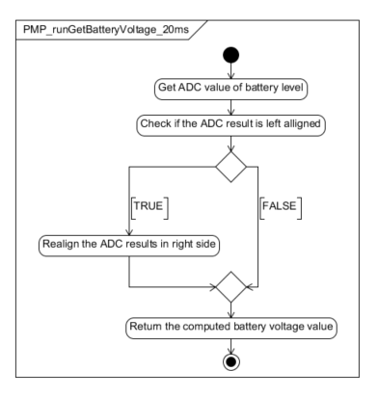

Figure PMP_runGetBatteryVoltage_20ms

### pmp_runGetBatteryVoltage_100ms

|  |  |  |
| --- | --- | --- |
| Object | | |
| The function shall provide the Battery Voltage filtered for 100ms periodic use | | |
| **Prototype** | | |
| void pmp_runGetBatteryVoltage_100 (u16VoltageType * pu16Voltage) | | |
| **Input parameters** | | |
| Name | Type | Description |
| NA | NA | NA |
| **Output parameters** | | |
| Name | Type | Description |
| pu16Voltage | u16VoltageType | Pointer used to store the requested result |
| **Return value** | | |
| Type | Description | |
| NA | void | |
| **Dynamic aspect** | | |
| Who(callers) | Description | |
| * | * | |
| **Static aspect** | | |
| NA | | |
| **Constrains** | | |
| NA | | |

Figure PMP_runGetBatteryVoltage_100ms

### pmp_runGetBatteryVoltage_10ms

|  |  |  |
| --- | --- | --- |
| Object | | |
| The function shall provide the Battery Voltage filtered for 10ms periodic use | | |
| **Prototype** | | |
| void pmp_runGetBatteryVoltage (u16VoltageType * pu16Voltage) | | |
| **Input parameters** | | |
| Name | Type | Description |
| NA | NA | NA |
| **Output parameters** | | |
| Name | Type | Description |
| pu16Voltage | u16VoltageType | Pointer used to store the requested result |
| **Return value** | | |
| Type | Description | |
| NA | void | |
| **Dynamic aspect** | | |
| Who(callers) | Description | |
| * | * | |
| **Static aspect** | | |
| NA | | |
| **Constrains** | | |
| NA | | |

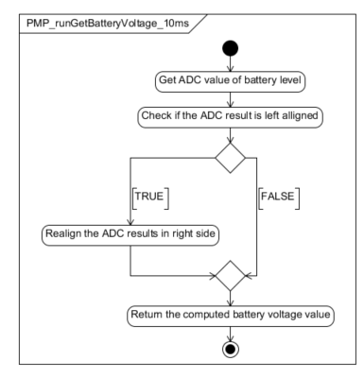

Figure PMP_runGetBatteryVoltage_10ms

### pmp_runGetBatteryVoltage_2ms

|  |  |  |
| --- | --- | --- |
| Object | | |
| The function shall provide the Battery Voltage filtered for 2ms periodic use | | |
| **Prototype** | | |
| void pmp_runGetBatteryVoltage (u16VoltageType * pu16Voltage) | | |
| **Input parameters** | | |
| Name | Type | Description |
| NA | NA | NA |
| **Output parameters** | | |
| Name | Type | Description |
| pu16Voltage | u16VoltageType | Pointer used to store the requested result |
| **Return value** | | |
| Type | Description | |
| NA | void | |
| **Dynamic aspect** | | |
| Who(callers) | Description | |
| * | * | |
| **Static aspect** | | |
| NA | | |
| **Constrains** | | |
| NA | | |

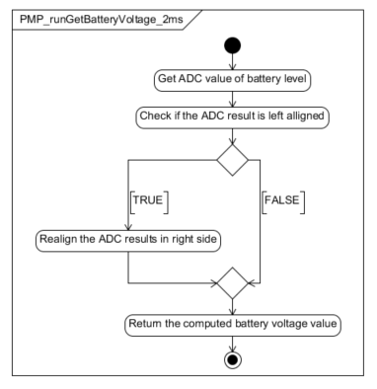

Figure PMP_runGetBatteryVoltage_2ms

### PMP_runGetBoardResistance

|  |  |  |
| --- | --- | --- |
| Object | | |
| The function is called to provide the ECU Resistance. | | |
| **Prototype** | | |
| EXPORTED void PMP_runGetBoardResistance (u16InternalTemperatureType u16ECUInternalTemperature, u16Resistance_mOhmType *pu16Resistance_mOhm) | | |
| **Input parameters** | | |
| Name | Type | Description |
| u16ECUInternalTemperature | u16InternalTemperatureType | NA |
| **Output parameters** | | |
| Name | Type | Description |
| pu16Resistance_mOhm | u16Resistance_mOhmType* | NA |
| **Return value** | | |
| Type | Description | |
| NA | - | |
| **Dynamic aspect** | | |
| Who(callers) | Description | |
| * | * | |
| **Static aspect** | | |
|  | | |
| **Constrains** | | |
|  | | |

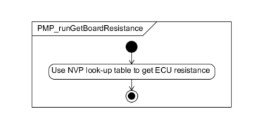

Figure PMP_runGetBoardResistance

### PMP_runGetMotorVn

|  |  |  |
| --- | --- | --- |
| Object | | |
| The function shall be used to get the V- voltage value from Half bridge power stage. | | |
| **Prototype** | | |
| void PMP_runGetMotorVn (u16VoltageType *pu16Voltage) | | |
| **Input parameters** | | |
| Name | Type | Description |
| NA | NA | NA |
| **Output parameters** | | |
| Name | Type | Description |
| pu16Voltage | u16VoltageType* | NA |
| **Return value** | | |
| Type | Description | |
| NA | - | |
| **Dynamic aspect** | | |
| Who(callers) | Description | |
| * | * | |
| **Static aspect** | | |
|  | | |
| **Constrains** | | |
|  | | |
|  |  |  |

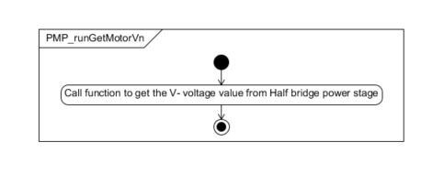

Figure PMP_runGetMotorVn

### PMP_runGetMotorVn_20ms

|  |  |  |
| --- | --- | --- |
| Object | | |
| The function shall be used to get the V- voltage value from Half bridge power stage filtered for 20ms periodic use. | | |
| **Prototype** | | |
| void PMP_runGetMotorVn_20ms (u16VoltageType *pu16Voltage) | | |
| **Input parameters** | | |
| Name | Type | Description |
| NA | NA | NA |
| **Output parameters** | | |
| Name | Type | Description |
| pu16Voltage | u16VoltageType* | NA |
| **Return value** | | |
| Type | Description | |
| NA | - | |
| **Dynamic aspect** | | |
| Who(callers) | Description | |
| * | * | |
| **Static aspect** | | |
|  | | |
| **Constrains** | | |
|  | | |
|  |  |  |



Figure PMP_runGetMotorVn_20ms

### PMP_runGetMotorVn_100ms

|  |  |  |
| --- | --- | --- |
| Object | | |
| The function shall be used to get the V- voltage value from Half bridge power stage filtered for 100ms periodic use. | | |
| **Prototype** | | |
| void PMP_runGetMotorVn_100ms (u16VoltageType *pu16Voltage) | | |
| **Input parameters** | | |
| Name | Type | Description |
| NA | NA | NA |
| **Output parameters** | | |
| Name | Type | Description |
| pu16Voltage | u16VoltageType* | NA |
| **Return value** | | |
| Type | Description | |
| NA | - | |
| **Dynamic aspect** | | |
| Who(callers) | Description | |
| * | * | |
| **Static aspect** | | |
|  | | |
| **Constrains** | | |
|  | | |
|  |  |  |



Figure PMP_runGetMotorVn_100ms

### PMP_runGetMotorVp

|  |  |  |
| --- | --- | --- |
| Object | | |
| The function shall be used to get the V+ voltage value from Half bridge power stage. | | |
| **Prototype** | | |
| EXPORTED void PMP_runGetMotorVp (u16VoltageType *pu16Voltage) | | |
| **Input parameters** | | |
| Name | Type | Description |
| NA | NA | NA |
| **Output parameters** | | |
| Name | Type | Description |
| pu16Voltage | u16VoltageType* | NA |
| **Return value** | | |
| Type | Description | |
| NA | - | |
| **Dynamic aspect** | | |
| Who(callers) | Description | |
| * | * | |
| **Static aspect** | | |
|  | | |
| **Constrains** | | |
|  | | |
|  |  |  |

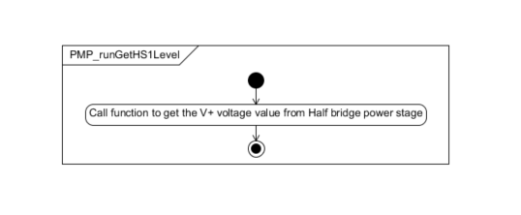

Figure PMP_runGetMotorVp

### PMP_runGetMotorVp_20ms

|  |  |  |
| --- | --- | --- |
| Object | | |
| The function shall be used to get the V+ voltage value from Half bridge power stage filtered for 20ms periodic use. | | |
| **Prototype** | | |
| EXPORTED void PMP_runGetMotorVp_20ms (u16VoltageType *pu16Voltage) | | |
| **Input parameters** | | |
| Name | Type | Description |
| NA | NA | NA |
| **Output parameters** | | |
| Name | Type | Description |
| pu16Voltage | u16VoltageType* | NA |
| **Return value** | | |
| Type | Description | |
| NA | - | |
| **Dynamic aspect** | | |
| Who(callers) | Description | |
| * | * | |
| **Static aspect** | | |
|  | | |
| **Constrains** | | |
|  | | |
|  |  |  |



Figure PMP_runGetMotorVp_20ms

### PMP_runGetMotorVp_100ms

|  |  |  |
| --- | --- | --- |
| Object | | |
| The function shall be used to get the V+ voltage value from Half bridge power stage filtered for 100ms periodic use. | | |
| **Prototype** | | |
| EXPORTED void PMP_runGetMotorVp_100ms (u16VoltageType *pu16Voltage) | | |
| **Input parameters** | | |
| Name | Type | Description |
| NA | NA | NA |
| **Output parameters** | | |
| Name | Type | Description |
| pu16Voltage | u16VoltageType* | NA |
| **Return value** | | |
| Type | Description | |
| NA | - | |
| **Dynamic aspect** | | |
| Who(callers) | Description | |
| * | * | |
| **Static aspect** | | |
|  | | |
| **Constrains** | | |
|  | | |
|  |  |  |



Figure PMP_runGetMotorVp_100ms

### PMP_runGetHS1Level

|  |  |  |
| --- | --- | --- |
| Object | | |
| The function shall be used to compute the value of the HighSide Switch Voltage level. | | |
| **Prototype** | | |
| EXPORTED void PMP_runGetHS1Level (u16VoltageType *pu16Voltage) | | |
| **Input parameters** | | |
| Name | Type | Description |
| NA | NA | NA |
| **Output parameters** | | |
| Name | Type | Description |
| pu16Voltage | u16VoltageType* | NA |
| **Return value** | | |
| Type | Description | |
| NA | - | |
| **Dynamic aspect** | | |
| Who(callers) | Description | |
| * | * | |
| **Static aspect** | | |
|  | | |
| **Constrains** | | |
|  | | |
|  |  |  |

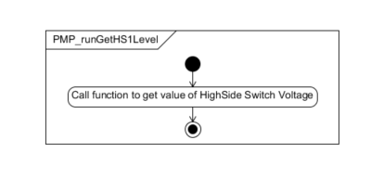

Figure PMP_runGetHS1Level

### PMP_runGetBatteryVoltageSurveyStatus

|  |  |  |
| --- | --- | --- |
| Object | | |
| The function shall be used to return the value of the battery voltage survey status. | | |
| **Prototype** | | |
| void PMP_runGetBatteryVoltageSurveyStatus (u8BatteryVoltageSurveyStatusType *pu8BatteryVoltageSurveyStatus) | | |
| **Input parameters** | | |
| Name | Type | Description |
| NA | NA | NA |
| **Output parameters** | | |
| Name | Type | Description |
| pu8BatteryVoltageSurveyStatus | u8BatteryVoltageSurveyStatusType* | NA |
| **Return value** | | |
| Type | Description | |
| NA | - | |
| **Dynamic aspect** | | |
| Who(callers) | Description | |
| * | * | |
| **Static aspect** | | |
|  | | |
| **Constrains** | | |
|  | | |
|  |  |  |

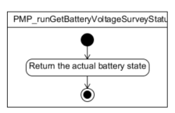

Figure PMP_runGetBatteryVoltageSurveyStatus

## Auto-Tests

### PMP_Autotest_CheckTemperatureSensor

|  |  |  |
| --- | --- | --- |
| Object | | |
| This auto-test aims at detecting an SBC temperature error. The temperature provided by the SBC module is compared to a low and high threshold. If the temperature value is out of range, this auto-test returns "failed" result, otherwise it returns "passed" result. | | |
| **Prototype** | | |
| void PMP_Autotest_CheckTemperatureSensor (u8TestResultType *pu8TestResult) | | |
| **Input parameters** | | |
| Name | Type | Description |
| NA | NA | NA |
| **Output parameters** | | |
| Name | Type | Description |
| pu8TestResult | u8TestResultType* | NA |
| **Return value** | | |
| Type | Description | |
| NA | - | |
| **Dynamic aspect** | | |
| Who(callers) | Description | |
| * | * | |
| **Static aspect** | | |
|  | | |
| **Constrains** | | |
|  | | |
|  |  |  |
|  |  |  |

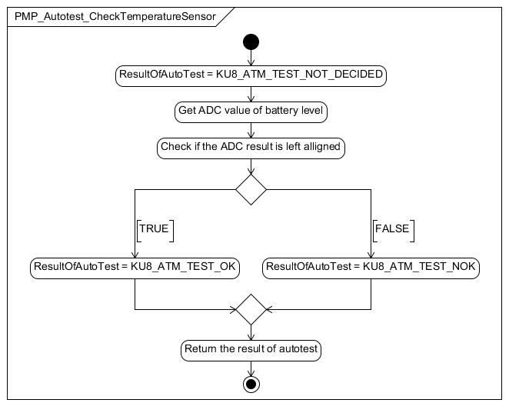

Figure PMP_Autotest_CheckTemperatureSensor

### PMP_Autotest_CheckPowerSupplyOV

|  |  |  |
| --- | --- | --- |
| Object | | |
| This is the test function for overvoltage on the Power stage battery voltage. | | |
| **Prototype** | | |
| void PMP_Autotest_CheckPowerSupplyOV(u8TestResultType * pu8TestResult) | | |
| **Input parameters** | | |
| Name | Type | Description |
| NA | NA | NA |
| **Output parameters** | | |
| Name | Type | Description |
| pu8TestResult | u8TestResultType | Pointer used to store the auto test result |
| **Return value** | | |
| Type | Description | |
| NA | void | |
| **Dynamic aspect** | | |
| Who(callers) | Description | |
| Called by ATM | * | |
| **Static aspect** | | |
| NA | | |
| **Constrains** | | |
| NA | | |

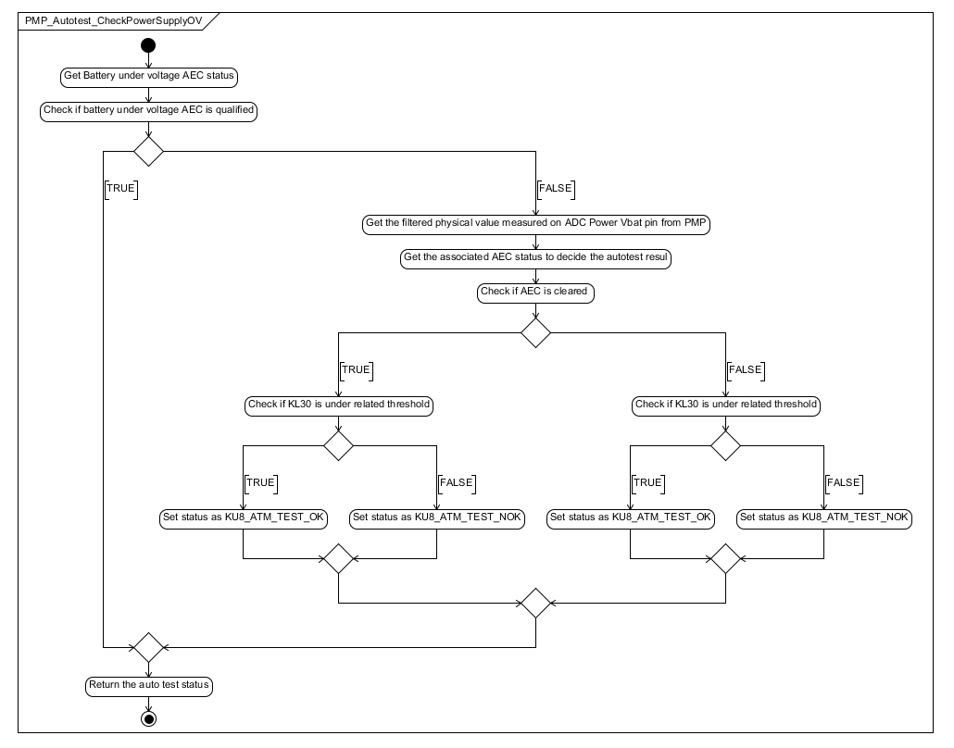

Figure PMP_Autotest_CheckPowerSupplyOV

### PMP_Autotest_CheckPowerSupplyUV

|  |  |  |
| --- | --- | --- |
| Object | | |
| The function shall check if an undervoltage is detected on the power stage of the battery voltage. | | |
| **Prototype** | | |
| void PMP_Autotest_CheckPowerSupplyUV (u8TestResultType *pu8TestResult) | | |
| **Input parameters** | | |
| Name | Type | Description |
| NA | NA | NA |
| **Output parameters** | | |
| Name | Type | Description |
| pu8TestResult | u8TestResultType* | NA |
| **Return value** | | |
| Type | Description | |
| NA | - | |
| **Dynamic aspect** | | |
| Who(callers) | Description | |
| * | * | |
| **Static aspect** | | |
|  | | |
| **Constrains** | | |
|  | | |

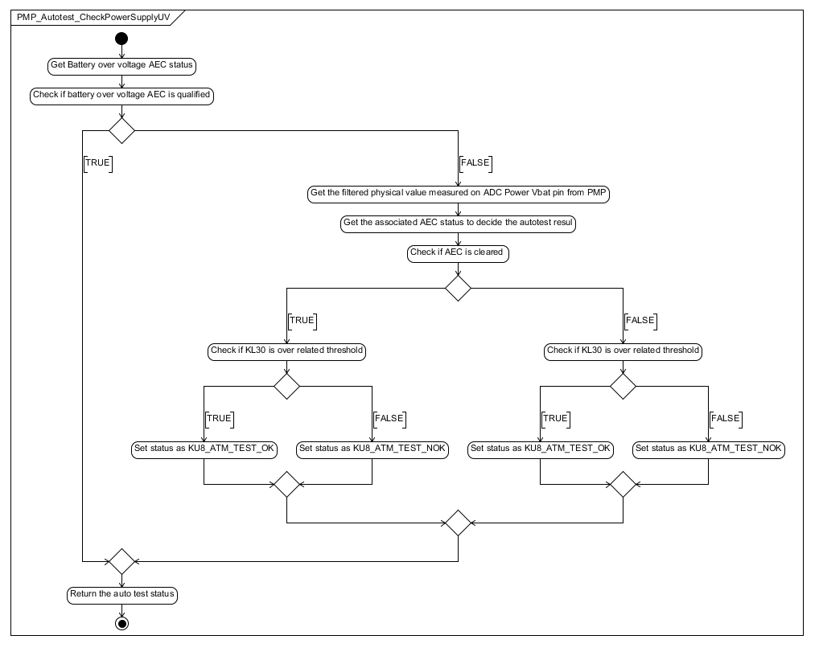

Figure PMP_Autotest_CheckPowerSupplyUV

### PMP_Autotest_CheckPowerSupplyUVDuringActivation

|  |  |  |
| --- | --- | --- |
| Object | | |
| The function shall check if an undervoltage is detected on the power stage of the battery voltage during a tensioning profile execution. | | |
| **Prototype** | | |
| void PMP_Autotest_CheckPowerSupplyUVDuringActivation (u8TestResultType *pu8TestResult) | | |
| **Input parameters** | | |
| Name | Type | Description |
| NA | NA | NA |
| **Output parameters** | | |
| Name | Type | Description |
| pu8TestResult | u8TestResultType* | NA |
| **Return value** | | |
| Type | Description | |
| NA | - | |
| **Dynamic aspect** | | |
| Who(callers) | Description | |
| * | * | |
| **Static aspect** | | |
|  | | |
| **Constrains** | | |
|  | | |

Figure PMP_Autotest_CheckPowerSupplyUVDuringActivation

### PMP_Autotest_CheckPowerSupplyOVDuringActivation

|  |  |  |
| --- | --- | --- |
| Object | | |
| This is the test function for overvoltage on the Power stage battery voltage during tensioning | | |
| **Prototype** | | |
| **void** **PMP_Autotest_CheckPowerSupplyOVDuringActivation**(u8TestResultType * pu8TestResult) | | |
| **Input parameters** | | |
| Name | Type | Description |
| NA | NA | NA |
| **Output parameters** | | |
| Name | Type | Description |
| pu8TestResult | u8TestResultType | Pointer used to store the auto test result |
| **Return value** | | |
| Type | Description | |
| NA | void | |
| **Dynamic aspect** | | |
| Who(callers) | Description | |
| Called by ATM | * | |
| **Static aspect** | | |
| NA | | |
| **Constrains** | | |
| NA | | |

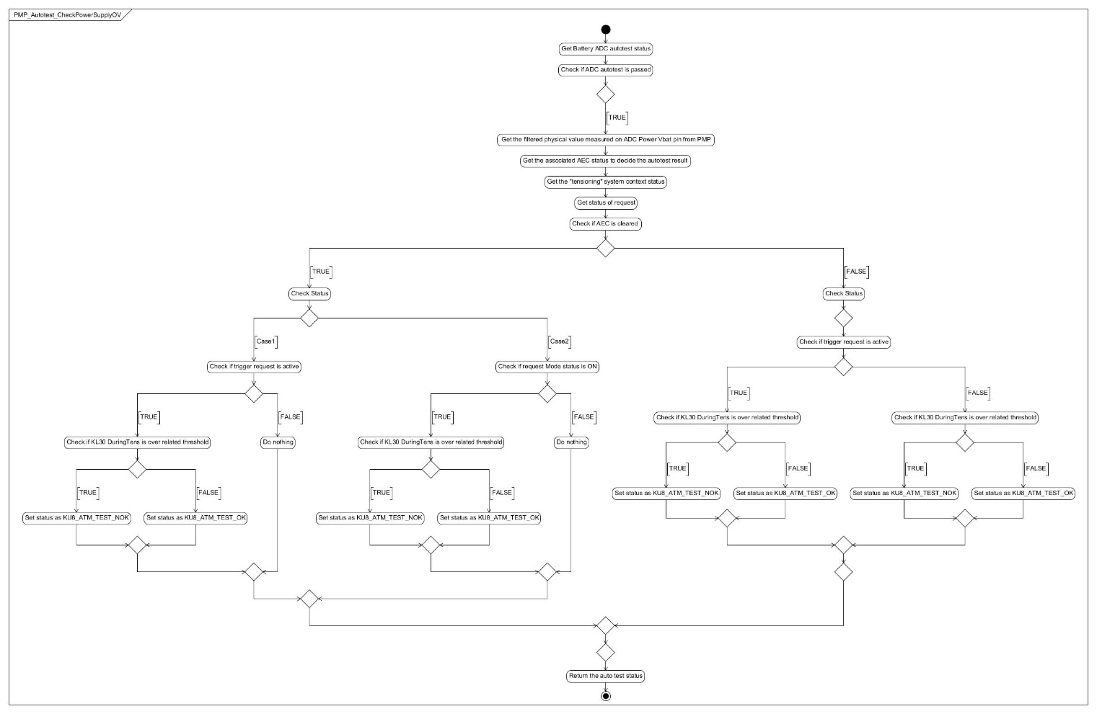

Figure PMP_Autotest_CheckPowerSupplyOVDuringActivation

### PMP_Autotest_CheckSystemUV

|  |  |  |
| --- | --- | --- |
| Object | | |
| This is the test function for undervoltage in the system. | | |
| **Prototype** | | |
| void PMP_Autotest_CheckSystemUV(u8TestResultType * pu8TestResult) | | |
| **Input parameters** | | |
| Name | Type | Description |
| NA | NA | NA |
| **Output parameters** | | |
| Name | Type | Description |
| pu8TestResult | u8TestResultType | Pointer used to store the auto test result |
| **Return value** | | |
| Type | Description | |
| NA | void | |
| **Dynamic aspect** | | |
| Who(callers) | Description | |
| Called by ATM | * | |
| **Static aspect** | | |
| NA | | |
| **Constrains** | | |
| NA | | |

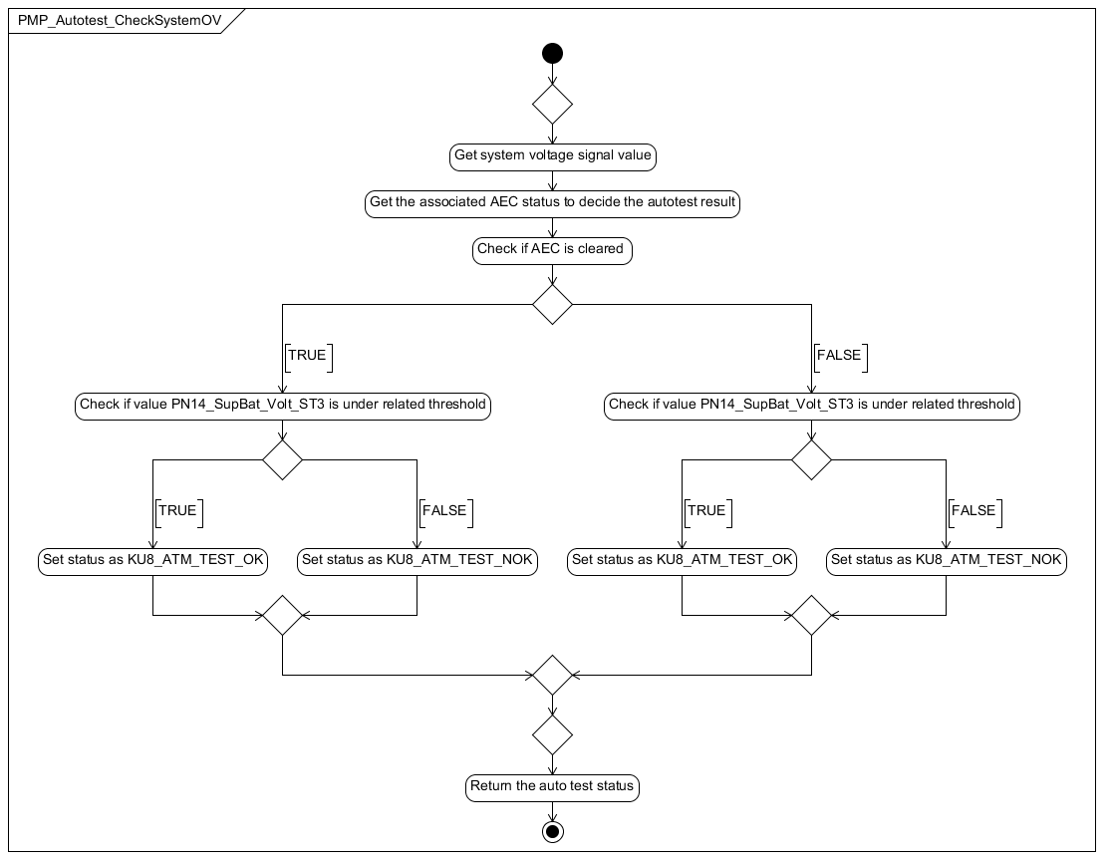

Figure PMP_Autotest_CheckSystemUV

### PMP_Autotest_CheckSystemOV

|  |  |  |
| --- | --- | --- |
| Object | | |
| This is the test function for overvoltage in the system. | | |
| **Prototype** | | |
| void PMP_Autotest_CheckSystemOV(u8TestResultType * pu8TestResult) | | |
| **Input parameters** | | |
| Name | Type | Description |
| NA | NA | NA |
| **Output parameters** | | |
| Name | Type | Description |
| pu8TestResult | u8TestResultType | Pointer used to store the auto test result |
| **Return value** | | |
| Type | Description | |
| NA | void | |
| **Dynamic aspect** | | |
| Who(callers) | Description | |
| Called by ATM | * | |
| **Static aspect** | | |
| NA | | |
| **Constrains** | | |
| NA | | |

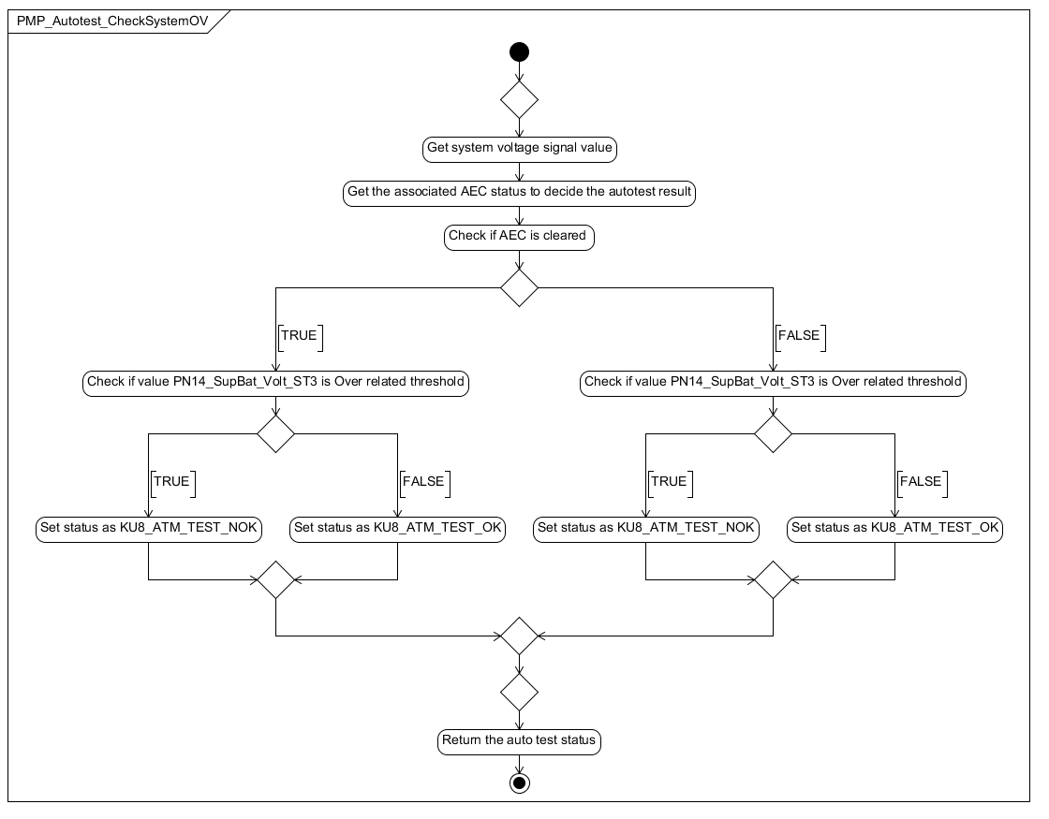

Figure PMP_Autotest_CheckSystemOV

## Types

### PMP_stBatterySurveyParamType

|  |  |  |
| --- | --- | --- |
| **Field Name** | **Field Type** | **Field description** |
| u16OldRawBatteryVoltage | uint16 | Previous battery voltage |
| u16MinBatteryVoltageADCFormat | uint16 | Minimum threshold for battery voltage |
| u16MaxBatteryVoltageADCFormat | uint16 | Maximum threshold for battery voltage |
| u16MinDiffVoltageToValidateBatterySurvey | uint16 | Voltage difference used in validation |
| u8CounterToValidateBatterySurvey | uint8 | Internal counter |
| u8BatteryVoltageSurveyState | u8BatteryVoltageSurveyStatusType | Battery Survey State |

## Variables

### PMP_stBatterySurveyParam

|  |  |  |
| --- | --- | --- |
| Type | Value |  |
| PMP_stBatterySurveyParamType | N.A. | |
| **Description** | | |
| Variable represents the structure containing all variables used by the battery survey mechanism | | |
| **Definition** | | |
| static PMP_stBatterySurveyParamType PMP_stBatterySurveyParam | | |

### PMP_u16OldADCTemperature_LSB

|  |  |  |
| --- | --- | --- |
| Type | Value |  |
| u16InternalTemperatureType | N.A. | |
| **Description** | | |
| Variable is used to store old temperature read from ADC | | |
| **Definition** | | |
| static u16InternalTemperatureType PMP_u16OldADCTemperature_LSB | | |

### PMP_u16OldCorrectedTemperature_LSB

|  |  |  |
| --- | --- | --- |
| Type | Value |  |
| u16InternalTemperatureType | N.A. | |
| **Description** | | |
| Variable is used to store old corrected temperature | | |
| **Definition** | | |
| static u16InternalTemperatureType PMP_u16OldCorrectedTemperature_LSB | | |

## Macros

### PMP_KU8_MOTOR_RESISTANCE_LINEAR_INTERPOLATION_NB_POINTS

|  |  |
| --- | --- |
| Name | Value |
| Motor resistance linear interpolation points number | 7 |
| **Definition** | |
| #define PMP_KU8_MOTOR_RESISTANCE_LINEAR_INTERPOLATION_NB_POINTS | |
| **Description** | |
| Number of points used in motor resistance linear interpolation | |

### PMP_RIGHT_ALIGNED_ADC

|  |  |
| --- | --- |
| Name | Value |
| ADC alignment to the right status | 0 |
| **Definition** | |
| #define PMP_RIGHT_ALIGNED_ADC | |
| **Description** | |
| Defines if the ADC result is right aligned | |

### PMP_LEFT_ALIGNED_ADC

|  |  |
| --- | --- |
| Name | Value |
| ADC alignment to the left status | 1 |
| **Definition** | |
| #define PMP_LEFT_ALIGNED_ADC | |
| **Description** | |
| Defines if the ADC result is left aligned | |

### PMP_ALIGNMENT_ADC_CHANNELS

|  |  |
| --- | --- |
| Name | Value |
| ADC Channels alignment | PMP_RIGHT_ALIGNED_ADC |
| **Definition** | |
| #define PMP_ALIGNMENT_ADC_CHANNELS | |
| **Description** | |
| ADC Channels alignment in the project | |

### PMP_KU16_ADC_10BIT_RANGE

|  |  |
| --- | --- |
| Name | Value |
| Range of 10-bit ADC | 1024 |
| **Definition** | |
| #define PMP_KU16_ADC_10BIT_RANGE | |
| **Description** | |
| Represents the maximum value a 10-bit ADC can have | |

### PMP_KU16_ADC_8BIT_RANGE

|  |  |
| --- | --- |
| Name | Value |
| Range of 8-bit ADC | 256 |
| **Definition** | |
| #define PMP_KU16_ADC_8BIT_RANGE | |
| **Description** | |
| Represents the maximum value a 8-bit ADC can have | |

### PMP_KU16_ADC_FULL_RANGE

|  |  |
| --- | --- |
| Name | Value |
| ADC full range | PMP_KU16_ADC_10BIT_RANGE |
| **Definition** | |
| #define PMP_KU16_ADC_FULL_RANGE | |
| **Description** | |
| Represents the full range of the ADC used in the project. | |

### PMP_KU16_ADC_REFERENCE_MV

|  |  |
| --- | --- |
| Name | Value |
| ADC reference in mV | 5000 |
| **Definition** | |
| #define PMP_KU16_ADC_REFERENCE_MV | |
| **Description** | |
| Represents the ADC voltage reference in mV | |

### PMP_KU32_HVI_INTERNAL_FACTOR

|  |  |
| --- | --- |
| Name | Value |
| HVI Internal Factor | 66 |
| **Definition** | |
| #define PMP_KU32_HVI_INTERNAL_FACTOR | |
| **Description** | |
| High Voltage Input factor internally applied by the MCU on high voltage analog inputs (mapped to KL30/KL30BG). | |

### PMP_KU32_KL30_RAW_MUL_FACTOR

|  |  |
| --- | --- |
| Name | Value |
| KL30 Raw Multiplication Factor | PMP_KU16_ADC_FULL_RANGE |
| **Definition** | |
| #define PMP_KU32_KL30_RAW_MUL_FACTOR | |
| **Description** | |
| KL30 & KL30bg conversion factors to be applied on voltage threshold parameter to convert from mV into 10 bits ADC raw format. | |

### PMP_KU32_KL30_RAW_DIV_FACTOR

|  |  |
| --- | --- |
| Name | Value |
| KL30 Raw Division Factor | (PMP_KU32_HVI_INTERNAL_FACTOR * PMP_KU16_ADC_REFERENCE_MV) / KU8_TEN) |
| **Definition** | |
| #define PMP_KU32_KL30_RAW_DIV_FACTOR | |
| **Description** | |
| KL30 & KL30bg conversion factors to be applied on voltage threshold parameter to convert from mV into 10 bits ADC raw format. | |

### PMP_KU32_KL30_MUL_FACTOR

|  |  |
| --- | --- |
| Name | Value |
| KL30 Multiplication Factor | (PMP_KU32_HVI_INTERNAL_FACTOR * PMP_KU16_ADC_REFERENCE_MV) / KU8_TEN |
| **Definition** | |
| #define PMP_KU32_KL30_MUL_FACTOR | |
| **Description** | |
| KL30 & KL30bg conversion factors to be applied on voltage threshold parameter to convert from mV into 10 bits ADC raw format. | |

### PMP_KU32_KL30_DIV_FACTOR

|  |  |
| --- | --- |
| Name | Value |
| KL30 Division Factor | PMP_KU16_ADC_FULL_RANGE |
| **Definition** | |
| #define PMP_KU32_KL30_DIV_FACTOR | |
| **Description** | |
| KL30 & KL30bg conversion factors to be applied on voltage threshold parameter to convert from mV into 10 bits ADC raw format. | |

### PMP_KU32_VN_MUL_FACTOR

|  |  |
| --- | --- |
| Name | Value |
| VN Multiplication Factor | 112 * PMP_KU16_ADC_REFERENCE_MV |
| **Definition** | |
| #define PMP_KU32_VN_MUL_FACTOR | |
| **Description** | |
| Motor V Minus conversion factor | |

### PMP_KU32_VN_DIV_FACTOR

|  |  |
| --- | --- |
| Name | Value |
| VN Division Factor | 12 * PMP_KU16_ADC_FULL_RANGE |
| **Definition** | |
| #define PMP_KU32_VN_DIV_FACTOR | |
| **Description** | |
| Motor V Minus conversion factor | |

### PMP_KU32_VP_MUL_FACTOR

|  |  |
| --- | --- |
| Name | Value |
| VP Multiplication Factor | 112 * PMP_KU16_ADC_REFERENCE_MV |
| **Definition** | |
| #define PMP_KU32_VP_MUL_FACTOR | |
| **Description** | |
| Motor V Plus conversion factor | |

### PMP_KU32_VP_DIV_FACTOR

|  |  |
| --- | --- |
| Name | Value |
| VP Division Factor | 12 * PMP_KU16_ADC_FULL_RANGE |
| **Definition** | |
| #define PMP_KU32_VP_DIV_FACTOR | |
| **Description** | |
| Motor V Plus conversion factor | |

### PMP_KU32_HS_MUL_FACTOR

|  |  |
| --- | --- |
| Name | Value |
| HS Multiplication Factor | 112 * PMP_KU16_ADC_REFERENCE_MV |
| **Definition** | |
| #define PMP_KU32_HS_MUL_FACTOR | |
| **Description** | |
| HS1 conversion factor | |

### PMP_KU32_HS_DIV_FACTOR

|  |  |
| --- | --- |
| Name | Value |
| HS Division Factor | 12 * PMP_KU16_ADC_FULL_RANGE |
| **Definition** | |
| #define PMP_KU32_HS_DIV_FACTOR | |
| **Description** | |
| HS1 conversion factor | |

### PMP_KU32_REFLOW_MUL_FACTOR

|  |  |
| --- | --- |
| Name | Value |
| REFLOW Multiplication Factor | PMP_KU16_ADC_REFERENCE_MV |
| **Definition** | |
| #define PMP_KU32_REFLOW_MUL_FACTOR | |
| **Description** | |
| Low reference conversion factor | |

### PMP_KU32_REFLOW_DIV_FACTOR

|  |  |
| --- | --- |
| Name | Value |
| REFLOW Division Factor | PMP_KU16_ADC_FULL_RANGE |
| **Definition** | |
| #define PMP_KU32_VP_DIV_FACTOR | |
| **Description** | |
| Low reference conversion factor | |

### PMP_KU32_REFMID_MUL_FACTOR

|  |  |
| --- | --- |
| Name | Value |
| REFMID Multiplication Factor | PMP_KU16_ADC_REFERENCE_MV |
| **Definition** | |
| #define PMP_KU32_REFMID_MUL_FACTOR | |
| **Description** | |
| Mid reference conversion factor | |

### PMP_KU32_REFMID_DIV_FACTOR

|  |  |
| --- | --- |
| Name | Value |
| REFMID Division Factor | PMP_KU16_ADC_FULL_RANGE |
| **Definition** | |
| #define PMP_KU32_REFMID_DIV_FACTOR | |
| **Description** | |
| Mid reference conversion factor | |

### PMP_KU32_REFHIGH_MUL_FACTOR

|  |  |
| --- | --- |
| Name | Value |
| REFHIGH Multiplication Factor | PMP_KU16_ADC_REFERENCE_MV |
| **Definition** | |
| #define PMP_KU32_REFHIGH_MUL_FACTOR | |
| **Description** | |
| High reference conversion factor | |

### PMP_KU32_REFHIGH_DIV_FACTOR

|  |  |
| --- | --- |
| Name | Value |
| REFHIGH Division Factor | PMP_KU16_ADC_FULL_RANGE |
| **Definition** | |
| #define PMP_KU32_REFHIGH_DIV_FACTOR | |
| **Description** | |
| High reference conversion factor | |

### PMP_KU32_REFCPUREG_MUL_FACTOR

|  |  |
| --- | --- |
| Name | Value |
| REFCPUREG Multiplication Factor | PMP_KU16_ADC_REFERENCE_MV |
| **Definition** | |
| #define PMP_KU32_REFCPUREG_MUL_FACTOR | |
| **Description** | |
| CPU Regulator Voltage conversion factor | |

### PMP_KU32_REFCPUREG_DIV_FACTOR

|  |  |
| --- | --- |
| Name | Value |
| REFCPUREG Division Factor | PMP_KU16_ADC_FULL_RANGE |
| **Definition** | |
| #define PMP_KU32_REFCPUREG_DIV_FACTOR | |
| **Description** | |
| CPU Regulator Voltage conversion factor | |

### PMP_KU16_ADC_RANGE_MV

|  |  |
| --- | --- |
| Name | Value |
| ADC Range (mV) | 5000 |
| **Definition** | |
| #define KU16_ADC_RANGE_MV | |
| **Description** | |
| ADC input full scale in mV (ADC reference voltage) | |

### PMP_KU16_ADC_OUT_SCALE

|  |  |
| --- | --- |
| Name | Value |
| ADC Out Scale | 1024 |
| **Definition** | |
| #define KU16_ADC_OUT_SCALE | |
| **Description** | |
| ADC full scale output value | |

### PMP_KU8_NB_INTERP_PTS_TEMP_CALIB

|  |  |
| --- | --- |
| Name | Value |
| Number of points in temperature calibration. | 7 |
| **Definition** | |
| #define PMP_KU8_NB_INTERP_PTS_TEMP_CALIB | |
| **Description** | |
| Number of points in temperature calibration. | |

### PMP_KU8_DEG_RANGE

|  |  |
| --- | --- |
| Name | Value |
| DEG Range | 135 |
| **Definition** | |
| #define PMP_KU8_DEG_RANGE | |
| **Description** | |
| DEG range | |

### PMP_KU8_DEG_LOW_RANGE

|  |  |
| --- | --- |
| Name | Value |
| DEG low range | 40 |
| **Definition** | |
| #define PMP_KU8_DEG_LOW_RANGE | |
| **Description** | |
| DEG low range | |

### PMP_KU32_TYP_H_SLOPE_UV_PER_DEG

|  |  |
| --- | --- |
| Name | Value |
| TYP H Slope UV per DEG | (PMP_KU32_TYP_SLOPE_UV_PER_DEG+1u)/2u |
| **Definition** | |
| #define PMP_KU32_TYP_H_SLOPE_UV_PER_DEG | |
| **Description** | |
| Half sensor's typical temperature slop (used to round division by PMP_KU16_ADC_OUT_SCALE) | |

### PMP_KU16_ADC_OUT_H_SCALE

|  |  |
| --- | --- |
| Name | Value |
| ADC Out H Scale | (PMP_KU16_ADC_OUT_SCALE+1u)/2u |
| **Definition** | |
| #define PMP_KU16_ADC_OUT_H_SCALE | |
| **Description** | |
| ADC half scale output value (used to round division by PMP_KU16_ADC_OUT_SCALE) | |

### PMP_KU32_ADC_RANGE_UV

|  |  |
| --- | --- |
| Name | Value |
| ADC Range UV | 1000 * MP_KU16_ADC_RANGE_MV |
| **Definition** | |
| #define PMP_KU32_ADC_RANGE_UV | |
| **Description** | |
| ADC input full scale in uV | |

### PMP_KU32_ADC_H_RANGE_UV

|  |  |
| --- | --- |
| Name | Value |
| ADC H Range UV | (PMP_KU32_ADC_RANGE_UV+1u)/2u |
| **Definition** | |
| #define PMP_KU32_ADC_H_RANGE_UV | |
| **Description** | |
| ADC input half scale in uV (used to round division by PMP_KU16_ADC_OUT_SCALE) | |

### PMP_KU32_REF_TEMP_UV

|  |  |
| --- | --- |
| Name | Value |
| REF Temperature UV | 1000 * PMP_KU16_REF_TEMP_MV |
| **Definition** | |
| #define PMP_KU32_REF_TEMP_UV | |
| **Description** | |
| Temperature sensor output in uV at its reference temperature | |

### PMP_KU32_ADC_INPUT_UV

|  |  |
| --- | --- |
| Name | Value |
| ADC Input UV | ((((output) * PMP_KU32_ADC_RANGE_UV) + PMP_KU16_ADC_OUT_H_SCALE) / PMP_KU16_ADC_OUT_SCALE) |
| **Definition** | |
| #define PMP_KU32_ADC_INPUT_UV(output) | |
| **Description** | |
| ADC input voltage in uV, for a given ADC output value | |

### PMP_KU32_ADC_OUTPUT

|  |  |
| --- | --- |
| Name | Value |
| ADC Output | ((((input_uv) * PMP_KU16_ADC_OUT_SCALE) + PMP_KU32_ADC_H_RANGE_UV) / PMP_KU32_ADC_RANGE_UV) |
| **Definition** | |
| #define PMP_KU32_ADC_OUTPUT(input_uv) | |
| **Description** | |
| ADC output value, for a given ADC input voltage in uV | |

### PMP_KU32_REF_TEMP_ADC

|  |  |
| --- | --- |
| Name | Value |
| Reference Temperature ADC | PMP_KU32_ADC_OUTPUT(PMP_KU32_REF_TEMP_UV) |
| **Definition** | |
| #define PMP_KU32_REF_TEMP_ADC | |
| **Description** | |
| Temperature sensor output raw value at its reference temperature | |

### PMP_KS16_ADC_TO_DEG

|  |  |
| --- | --- |
| Name | Value |
| ADC to Degree | (((PMP_KU8_DEG_RANGE * temp_adc) / PMP_KU16_ADC_OUT_SCALE)  - PMP_KU8_DEG_LOW_RANGE) |
| **Definition** | |
| #define PMP_KS16_ADC_TO_DEG(temp_adc) | |
| **Description** | |
| Macro to convert a temperature from ADC output scale to degrees C, using a given slope parameter in micro volt per degree before the reference point | |

### PMP_KU16_DEG_TO_ADC

|  |  |
| --- | --- |
| Name | Value |
| Degree to ADC | PMP_KU32_ADC_OUTPUT(PMP_KU32_REF_TEMP_UV - ((KU16_REF_TEMP_DEG - temp_deg) * (uint32)slope)) |
| **Definition** | |
| #define PMP_KU16_DEG_TO_ADC(temp_deg,slope) | |
| **Description** | |
| Macro to convert a temperature from degrees C to ADC output scale, using a given slope parameter in micro volt per degree before the reference point | |

### PMP_KU16_COMPUTE_TEMP_SLOP

|  |  |
| --- | --- |
| Name | Value |
| Compute Temperature Slop | (uint16)(((PMP_KU32_REF_TEMP_UV - KU32_ADC_INPUT_UV(temp_adc)) + ((((PMP_KU16_REF_TEMP_DEG-(temp_deg))+1u)/2u)+1u)) / (PMP_KU16_REF_TEMP_DEG-(temp_deg))) |
| **Definition** | |
| #define PMP_KU16_COMPUTE_TEMP_SLOP(temp_deg,temp_adc) | |
| **Description** | |
| Macro to compute a slop in uV/degree from the reference point using the real MCU temperature in degree and the ADC scaled temperature read | |

### PMP_KU16_FIX_TEMP_ADC

|  |  |
| --- | --- |
| Name | Value |
| Fix Temperature ADC | (uint16)(PMP_KU32_REF_TEMP_ADC - ((((PMP_KU32_REF_TEMP_ADC - temp_adc) * Typ_slope) + Cal_h_slope) / Cal_slope)) |
| **Definition** | |
| #define PMP_KU16_FIX_TEMP_ADC(temp_adc,Cal_slope,Cal_h_slope,Typ_slope) | |
| **Description** | |
| Macro to fix a temperature in ADC output scale:  - consider that for (temp_adc) temperature, the sensor observed the same slope as during the calibration (Cal_slope)  - the new output temperature will respect the sensor typical slope (Typ_slope) | |

### PMP_KU32_TYP_SLOPE_UV_PER_DEG

|  |  |
| --- | --- |
| Name | Value |
| TYP Slope UV per Degree | 5220 |
| **Definition** | |
| #define PMP_KU32_TYP_SLOPE_UV_PER_DEG | |
| **Description** | |
| Sensor's typical temperature slop in uV/degree C | |

### PMP_KU16_REF_TEMP_DEG

|  |  |
| --- | --- |
| Name | Value |
| Reference Temperature Degree | 150 |
| **Definition** | |
| #define PMP_KU16_REF_TEMP_DEG | |
| **Description** | |
| Temperature sensor's reference temperature in degree C | |

### PMP_KU16_REF_TEMP_MV

|  |  |
| --- | --- |
| Name | Value |
| Reference of temperature in mV | 2250 |
| **Definition** | |
| #define PMP_KU16_REF_TEMP_MV | |
| **Description** | |
| Temperature sensor output in mV at its reference temperature | |

### PMP_KS16_TEMP_HIGH

|  |  |
| --- | --- |
| Name | Value |
| Temperature high | 35 |
| **Definition** | |
| #define PMP_KS16_TEMP_HIGH | |
| **Description** | |
| High threshold for temperature | |

### PMP_KU32_TWO

|  |  |
| --- | --- |
| Name | Value |
| TWO | 2 |
| **Definition** | |
| #define PMP_KU32_TWO | |
| **Description** | |
| Internal macro for number 2 | |

### PMP_KU32_ONE_HUNDRED

|  |  |
| --- | --- |
| Name | Value |
| ONE HUNDRED | 100 |
| **Definition** | |
| #define PMP_KU32_ONE_HUNDRED | |
| **Description** | |
| Internal macro for number 100 | |

### PMP_KU16_ADC_LEFT_ALIGNED_BIT_SHIFT

|  |  |
| --- | --- |
| Name | Value |
| 6 bits Shift for left coded Raw values | 64 |
| **Definition** | |
| #define PMP_KU16_ADC_LEFT_ALIGNED_BIT_SHIFT | |
| **Description** | |
| 6 bits Shift for left coded Raw values | |

### PMP_KU16_FIVE_HUNDRED

|  |  |
| --- | --- |
| Name | Value |
| PMP_KU16_FIVE_HUNDRED | 500U |
| **Definition** | |
| #define PMP_KU16_FIVE_HUNDRED | |
| **Description** | |
| Define used to convert system voltage variable | |

### PMP_KU8_NO_REQUEST

|  |  |
| --- | --- |
| Name | Value |
| PMP_KU8_NO_REQUEST | 255U |
| **Definition** | |
| #define PMP_KU8_NO_REQUEST | |
| **Description** | |
| Define used to check if any request is active or not | |

# EEPROM

The EEPROM parameters are all specified in NVP_param config .xls

Refer to this document for more details.

# Configuration

No special configuration for PMP software component.

# Compilation Options

No special configuration for PMP software component.